Lab Session – Day 3

**Question:**

Use classicmodels database attached herewith.



Execute the code as it is and refresh the schema to see it in your system.

Find the country names beginning with letter A, letter B and letter C from customers table. The output should look as shown in below image.

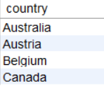

**Solution:**

Write the below query in MySQL workbench.

